Claude Desktop - Intune Deployment Guide
This guide covers deploying Claude Desktop as a Win32 app via Microsoft Intune. Before you start, download the Claude Desktop MSIX from https://claude.ai/download and package it using the steps in the README. You should have an install_claude.intunewin file ready to upload before proceeding.

Step 1 - App information
Go to Intune admin centre > Apps > All apps > Add. Select Windows app (Win32) and upload your install_claude.intunewin file. Fill in the app information fields as shown. Key values: Name = Claude Desktop - Full, Publisher = Anthropic. The app version will populate automatically from the package. Leave optional fields blank unless your BU has a specific naming convention.
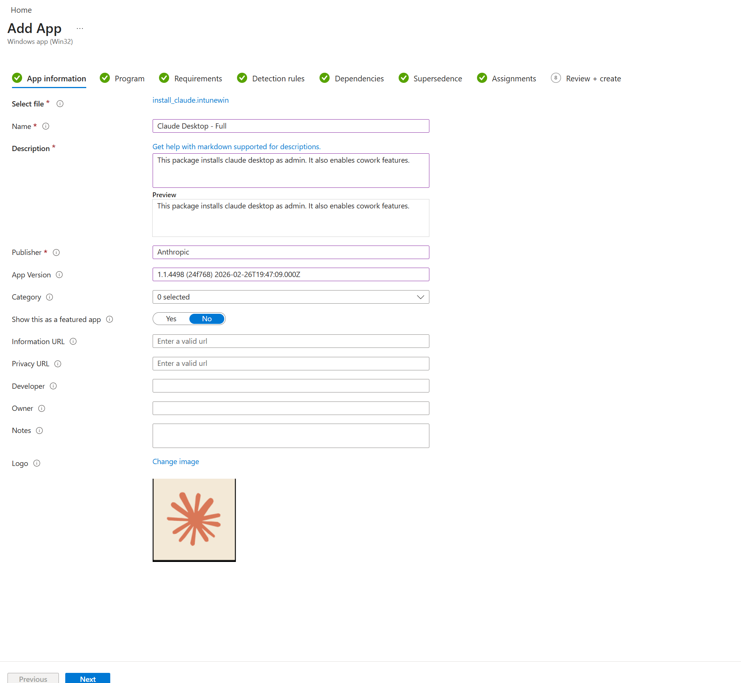

Step 2 - Program
Set the install and uninstall commands exactly as shown. Install behaviour must be set to System - the script uses Add-AppxProvisionedPackage which requires SYSTEM context and will not work if set to User. Leave device restart behaviour as No specific action. The return codes shown (0, 1707, 3010, 1641, 1618) cover success, soft reboot, hard reboot, and retry states. Add them as shown.
Install command: powershell.exe -ExecutionPolicy Bypass -File install_claude.ps1 -PackagePath ".\Claude.msix"
Uninstall command: powershell.exe -ExecutionPolicy Bypass -File uninstall_claude.ps1

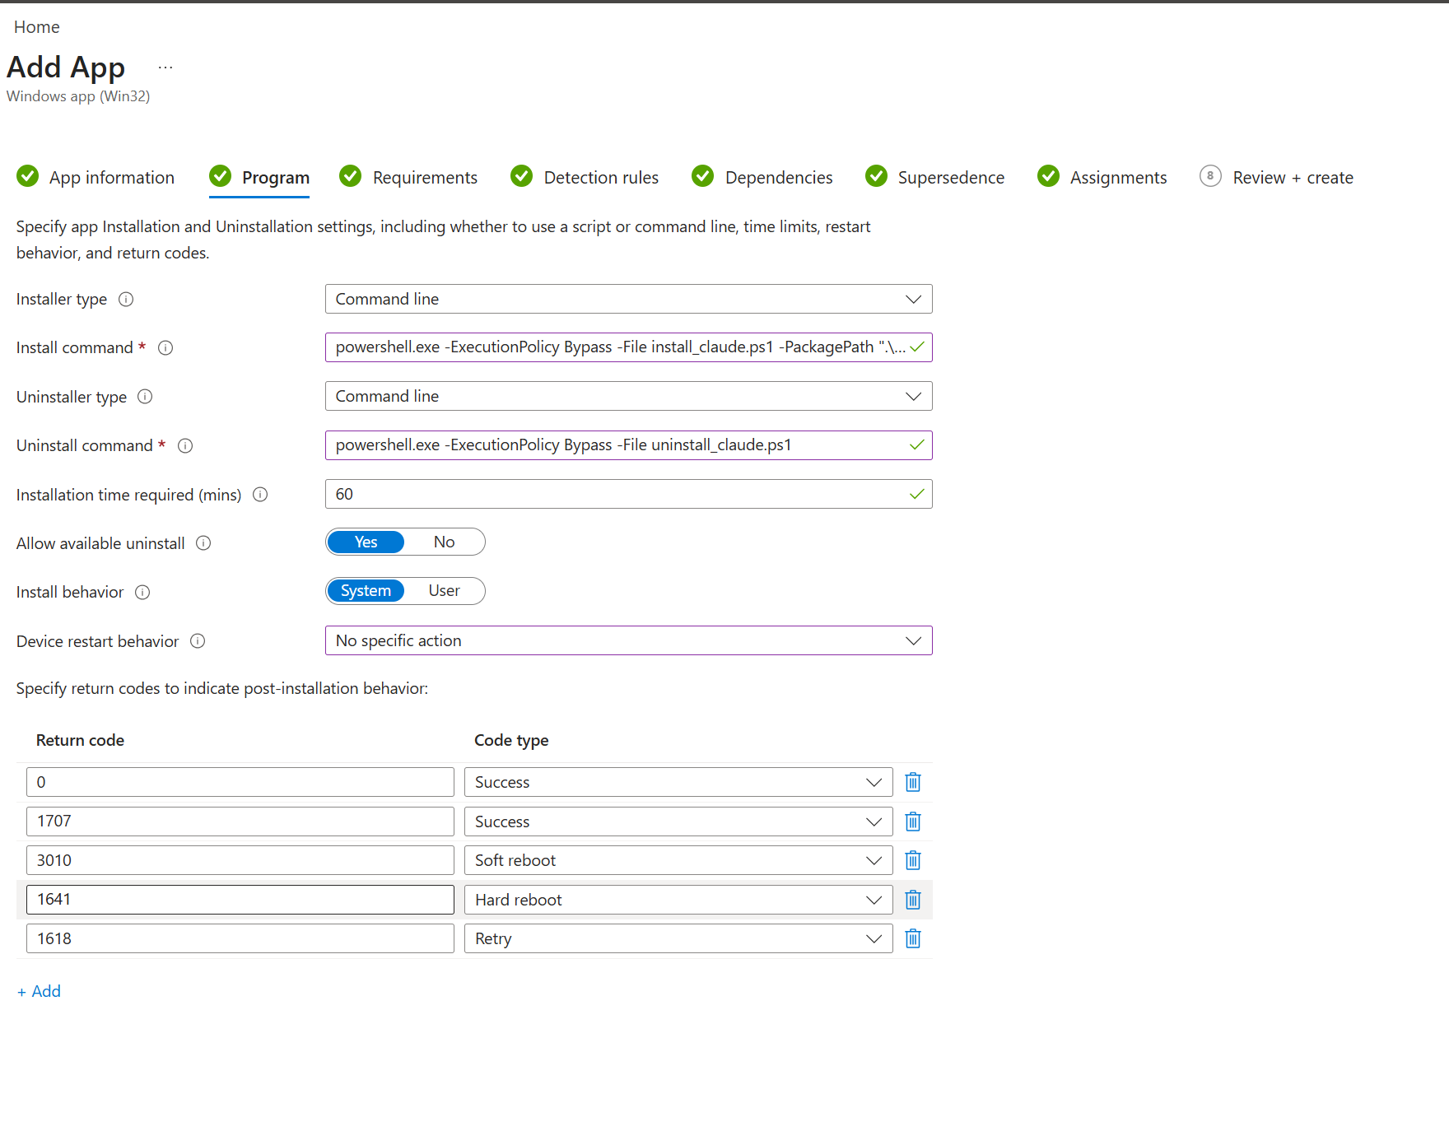

Step 3 - Requirements
Set the minimum operating system to Windows 10 2004. Leave OS architecture check as No to allow installation on all systems. No other requirement rules are needed for this deployment.
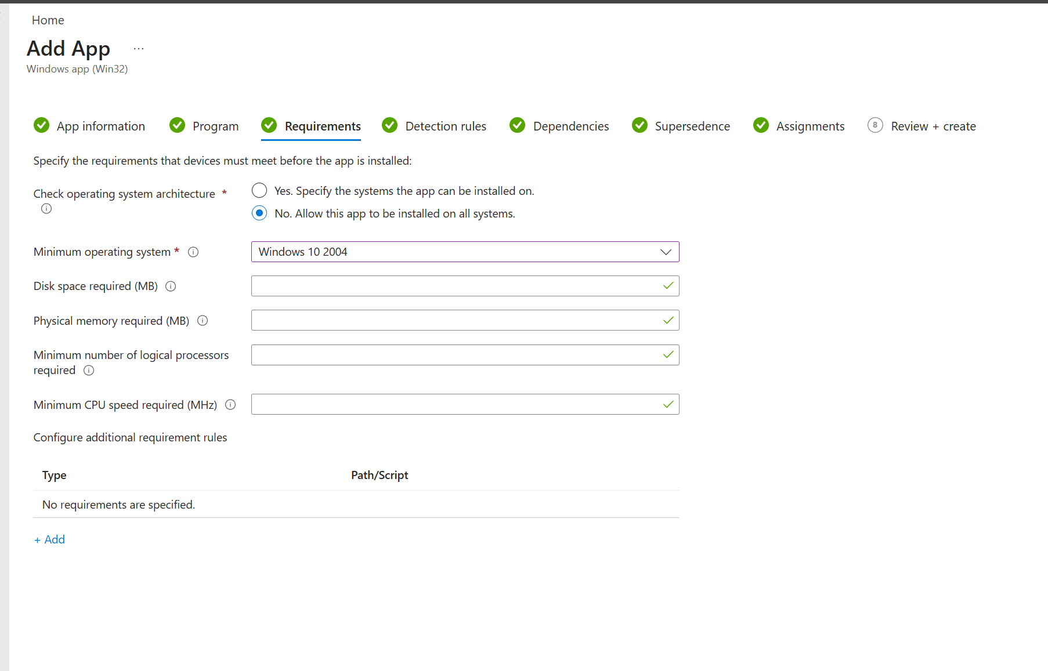

Step 4 - Detection rules
Set Rules format to Use a custom detection script and upload detect_claude.ps1. Set both toggles to No: do not run as 32-bit process, and do not enforce script signature check.
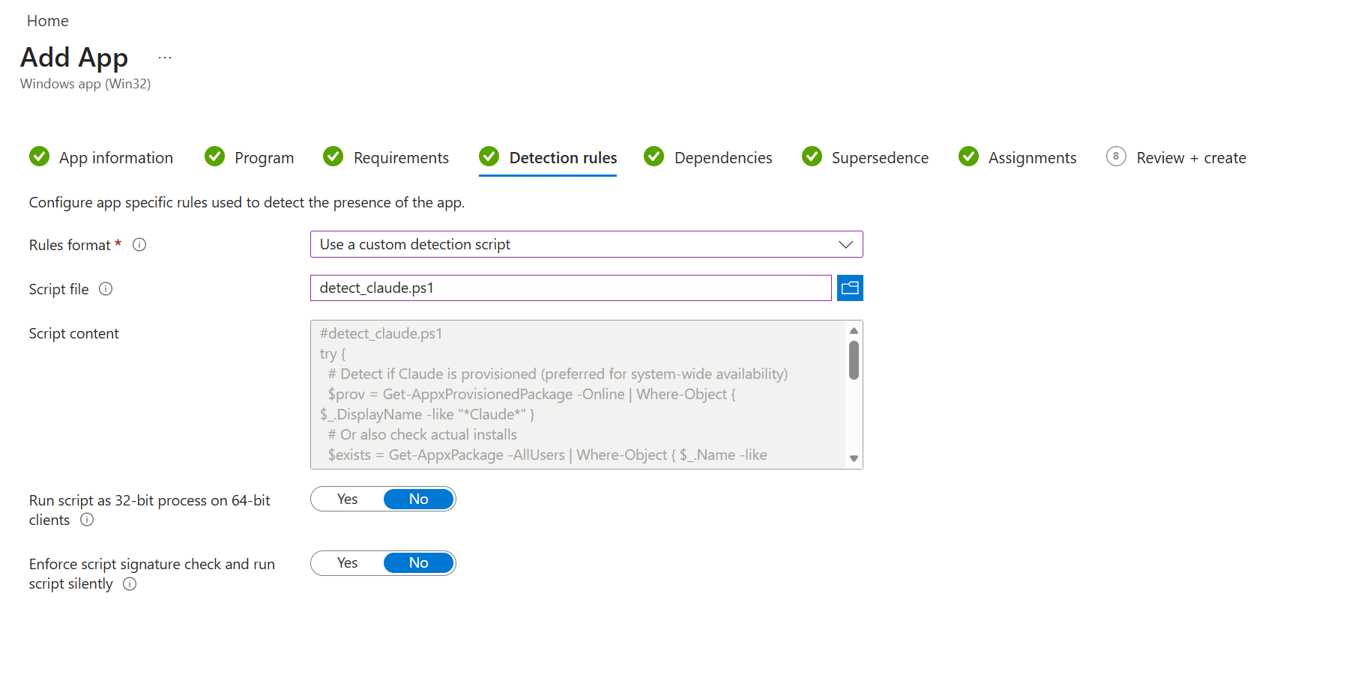

Step 5 - Dependencies
No dependencies are required for this deployment. Leave the list empty and click Next.
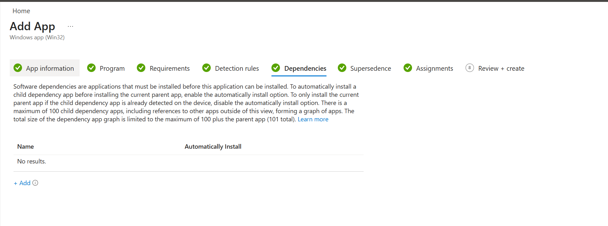

Step 6 - Supersedence
No supersedence rules are needed for a fresh deployment. If you are replacing an earlier version of Claude Desktop that was packaged differently, add it here so Intune removes it before installing this version. Otherwise leave empty and click Next.
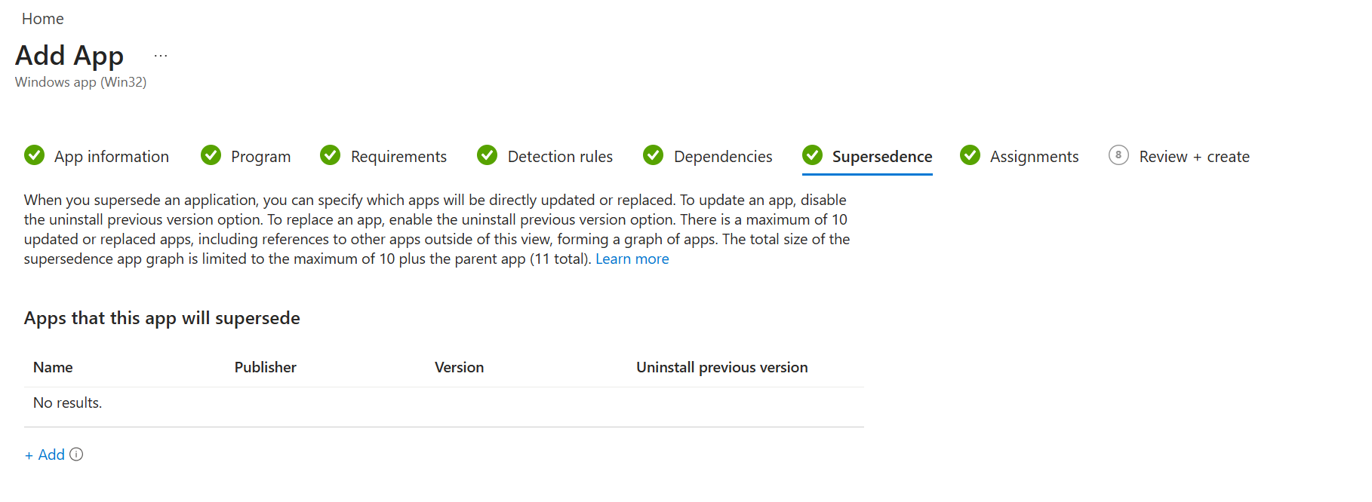

Step 7 - Assignments
Assign the app to device groups, not user groups. The MSIX is provisioned system-wide so device-based targeting is required. Three assignment groups are shown: Required (mandatory install), Available for enrolled devices (self-service), and Uninstall. Create matching Entra ID device groups for your BU before completing this step. Start with a pilot group under Required, confirm install status under Devices > Monitor > App install status, then broaden the Required assignment once verified.
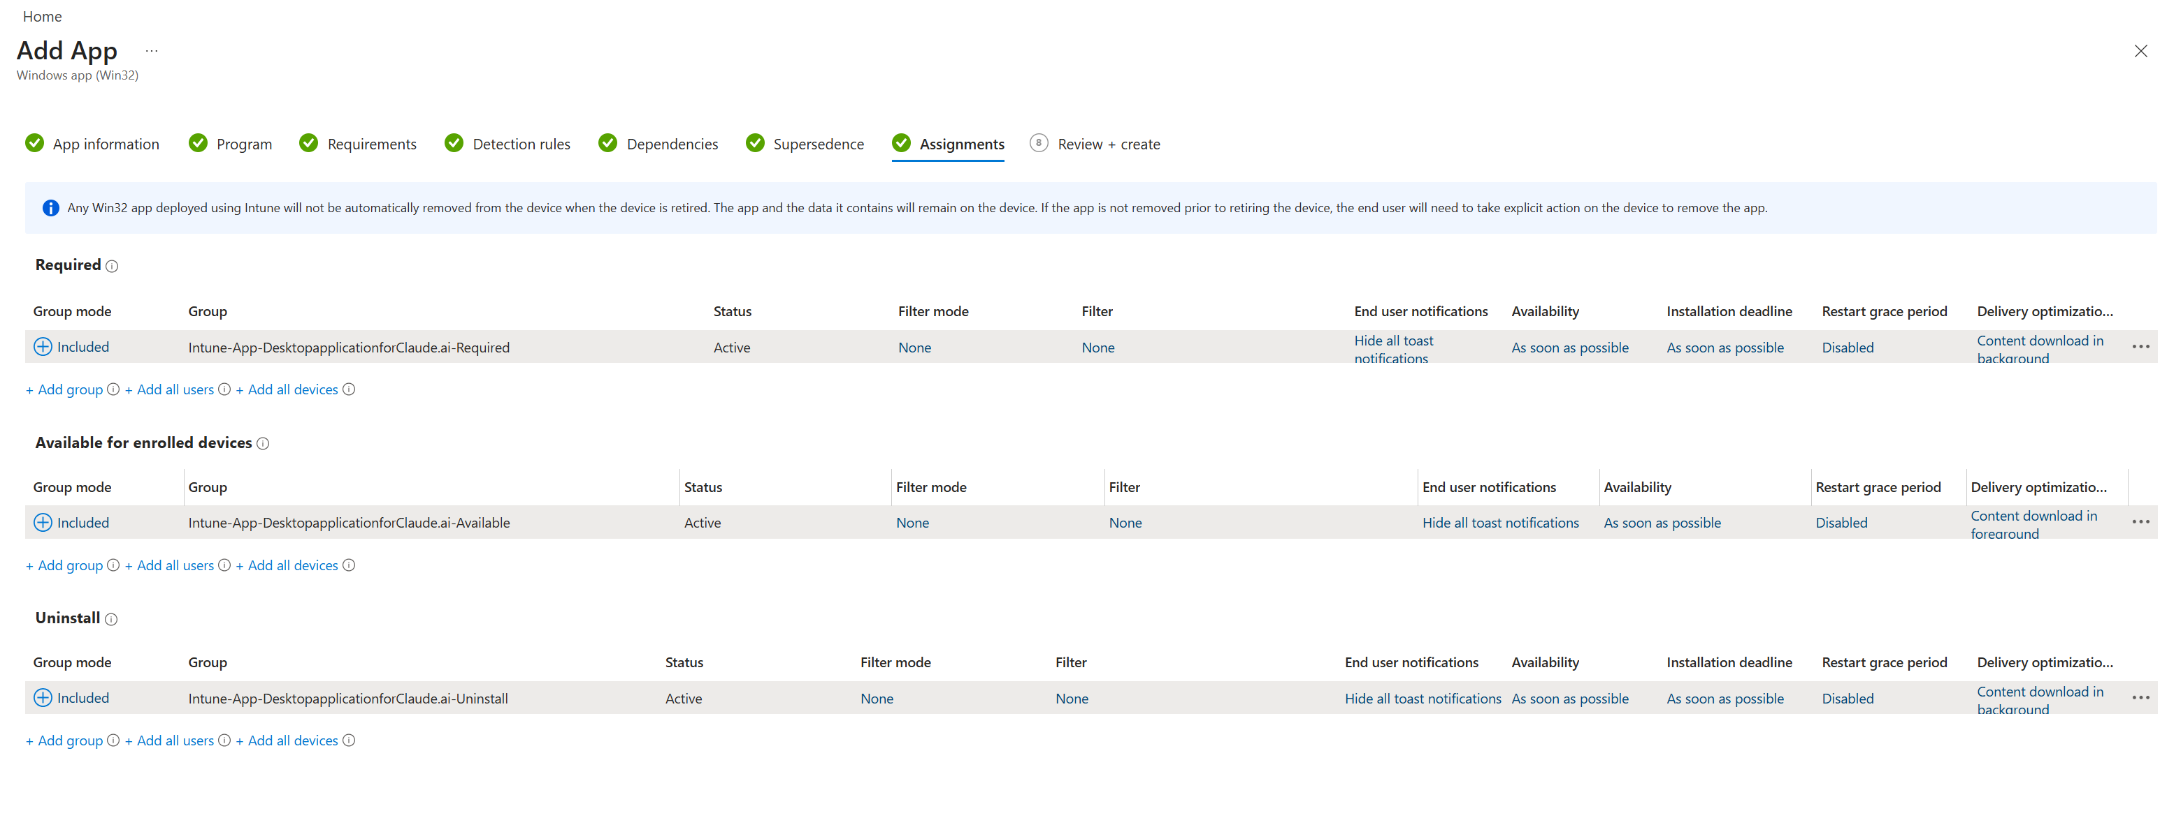

Step 8 - Review and create
Review the summary and confirm all settings match what is shown. Key things to check: install behaviour is System, install command references the correct script and MSIX filename, and your assignment groups are correct. Click Create when ready. Intune will begin deploying to assigned devices within the next sync cycle, typically within 15-30 minutes for online devices.
